AGREEMENT OF COOPERATION

Between:

Manhattan Institute of Management
Address:
110 William Street
New York, NY 10038 – U.S.A.
Hereinafter referred to as “MIM”
And

Department of Mechanics, Mathematics, and Management
Politecnico di Bari
Address:
Viale Japigia 182 - 70126 Bari- Italy
Hereinafter referred to as “DMMM”

Article 1: Agreement Purpose
The purpose of this agreement is to:
-Define relations between MIM and DMM.

Article 2: Objectives of the Agreement
Beginning in the January 2017 semester, which starts on January 9, 2017, DMM may students involved in the master course of Management Engineering interested to complete their study program in New York City for a period of six months at MIM in New York.

During that period, DMMM will regularly:

Promote the MIM program to DMMM students who wish to study business in the heart of Wall Street in New York City.

MIM will, for the same period:
Develop and organize programs in New York for DMMM students coming to MIM within the framework of, and as required by DMMM Bari students.

Provide MIM’s facilities, teaching staff, programs, teaching, and logistical support, including I-20 forms for visa issuance:

The program and classes will be scheduled at the following address: 110 William Street, 3rd Floor, New York, NY.

Article 3: Tuition Breakdown
For every session held in the USA, MIM shall receive 100% of the total tuition for all DMMM students enrolled in the New York program.

The tuition includes:

Six-month stay (318 clock hours)
USD $4,500 per student

This price includes: 318 hours of coursework via the Six-Month International Business Studies Program.

The tuition will be paid directly by students to MIM. Total tuition will be paid in two installments:

- Students will effect a payment of 50% upon the student’s reception of their visa.
- The other 50% will be paid by the student by the sixth week of the program.

Article 4- Other Details
MIM will deliver transcripts Politecnico de Bari and grades will be delivered based on the following scoring system:

A 94-100
A- 90-93
B+ 87-89
B 84-86
B- 80-83
C+ 77-79
C 74-76
C- 70-73
D+ 67-69
D 65-66
F 65 and below

MIM is responsible in finding and recruiting all instructors. MIM will hire instructors only on a per hour based contract.

Students are responsible for their own international coverage insurance and medical insurance.

Regular meetings will be held between DMMM and MIM to assess programs quality, students’ performance, and satisfaction level. This agreement shall last for three years. This Agreement shall be construed and governed in accordance with the Laws of New York State and SEVIS.

Date: 01/13/2017 Date: 01/13/2017

Accepted by: Accepted by:

For and behalf of MIM  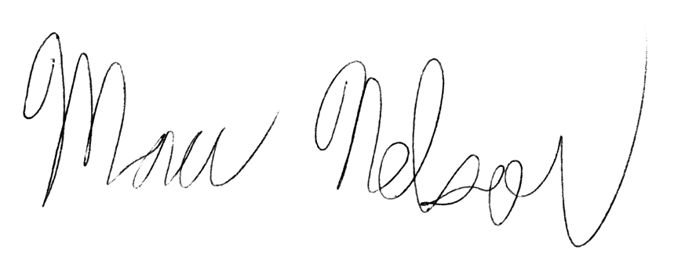 | For and behalf of DMMM  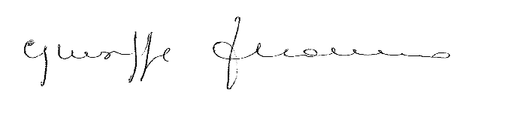
Marc Nelson  Director of Marketing  Manhattan Institute of Management  130 William Street, 3rd Floor  New York, NY 10038  http://www.mimusa.edu | Prof. Giuseppe Monno  Director of the Department of Mechanics, Mathematics, and Management  Politecnico di Bari  Viale Japigia 182 - 70126 Bari  http://www.en.poliba.it/

